1. Overview

In this challenge, you’ll construct a unique sculpture using a variety of Unity primitives that remains balanced even with gravity enabled.
To accomplish this task, you'll need to put your scene view navigation skills to the test, especially your ability to move, rotate, and scale objects in 3D space.
The real-world inspiration for your structure could range from an abstract rock sculpture to a giant modern tower. For example, how could you represent some of the structures below in Unity?


2. Review your primitive options

Before you get started building, it will be helpful to get an overview of all of the 3D primitive shapes at your disposal:
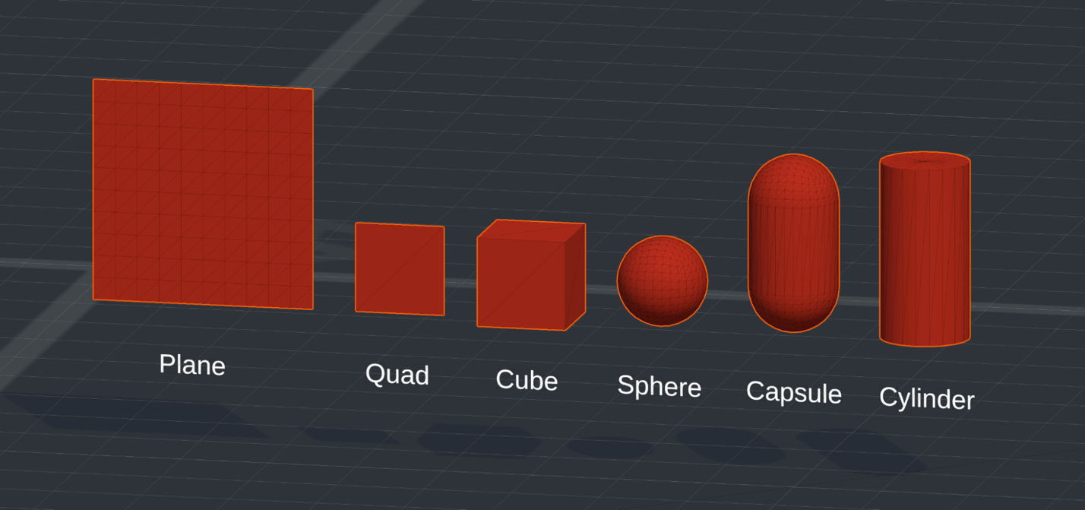
- Plane: A flat, rectangular surface with no height dimension, ideal for creating large-scale flat surfaces like floors or terrain in a 3D environment because it contains many vertices for detailed texturing and interaction. Only one side of the plane is rendered, making it invisible from behind.
- Quad: A flat, two-dimensional square with only two triangles, which is what separates it from a plane. It is suitable for simple, efficient flat surfaces or for displaying 2D elements in a 3D scene, like sprites and billboards, due to its lower complexity compared to a plane. Similar to the plane, only one side is rendered, making it invisible from behind.
- Cube: This object is useful for constructing a wide range of geometric structures due to its uniformity and simplicity.
- Sphere: This object is useful for simulating round objects like balls, planets, or character heads.
- Capsule: A cylinder capped with hemispheres at both ends, typically used for character collision detection in games.
- Cylinder: A 3D shape with two flat circular faces and a curved side, useful for simulating objects with a circular cross-section like tree trunks or barrels.

3. Tips and tricks
Below are a few very helpful tips before you get started building.
Create an empty parent GameObject to stay organized
In order to make sure that your structure stays nice and organized in the Hierarchy window, it is helpful to make an empty parent GameObject, then create all of your primitives as child GameObjects. To do this, right-click in the Hierarchy window and select Create Empty, rename the parent GameObject something like “Structure”, and reset the position to the origin.
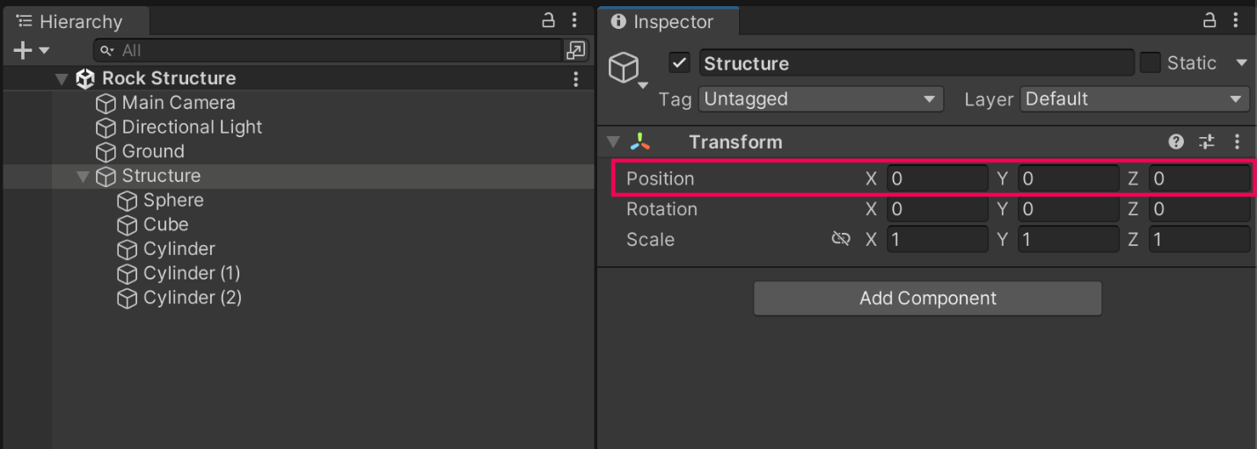
Then, simply right-click on the Parent GameObject in the Hierarchy window when you create new primitives and they will automatically be assigned as child GameObjects. This way, you’ll be able to easily move the entire object around with a single GameObject, and it will keep your Hierarchy window more neat.
Note: You can also drag one GameObject on top of another to make it a child GameObject. For efficiency, hold Ctrl (macOS: Cmd) to select multiple individual GameObjects or hold Shift to select a list of GameObjects. Check out the video below for a demonstration of this.
Use exact coordinates for precision
Sometimes you will want to make things perfectly symmetrical or perfectly spaced apart. Rather than just using the move tool in this situation, you can use the Transform properties to space objects precisely. For example, the cubes below are all spaced exactly two units apart on the X axis.
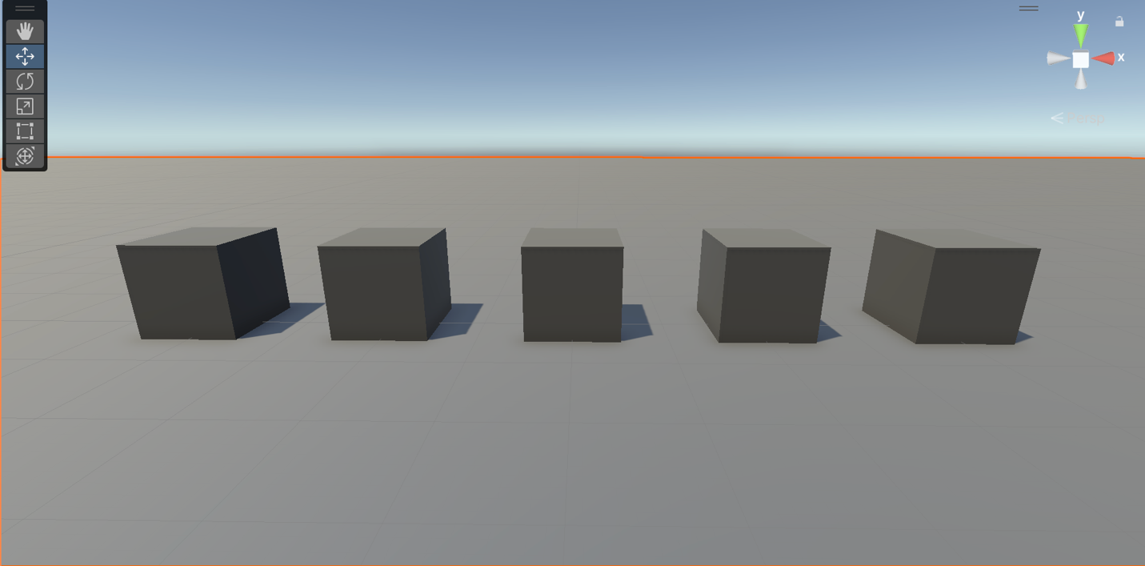
Use Rigidbody mass for balancing
If you make an object larger, it does not make it heavier. To make it heavier, you need to adjust the Mass property in the Rigidbody component, which defines the object’s weight in kilograms. In the example below, the cylinders only balance because the two cylinders on the left have a mass of 1kg, while the cylinder on the right has a mass of 2kg.
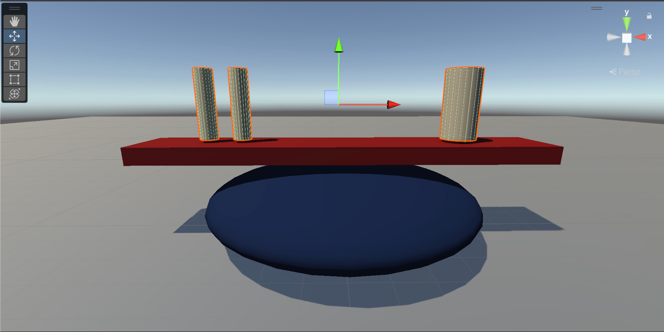
Use Mesh Colliders for unusual primitives
A collider is a component in Unity that defines the shape of an object for the purposes of physical interactions with other objects in the scene. The collider determines the actual shape for building and balancing purposes — the mesh is simply a visual representation.
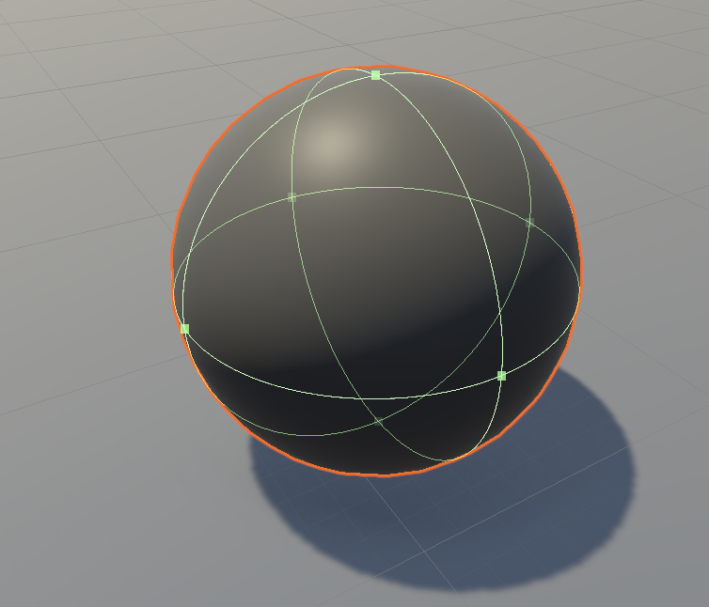
However, there are some situations where the mesh will not match the collider, such as with a cylinder. The cylinder primitive actually uses a capsule-shaped collider, which makes it difficult to use for building, since it doesn’t actually have any flat surfaces on the collider.
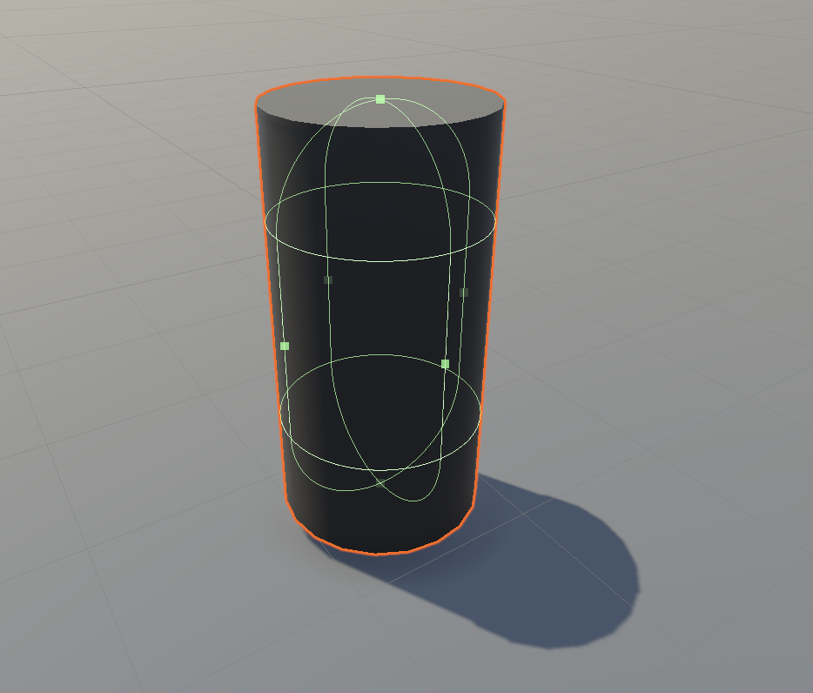
In situations like this, you can use something called a Mesh Collider component, which uses the actual mesh to define the shape of an object for physics interactions. When the Convex property is enabled, the mesh is treated as a convex shape, offering improved performance but potentially sacrificing some accuracy compared to a non-convex mesh collider. Check out the image below to see how the Mesh Collider component wraps more accurately around the mesh than the Capsule Collider component.
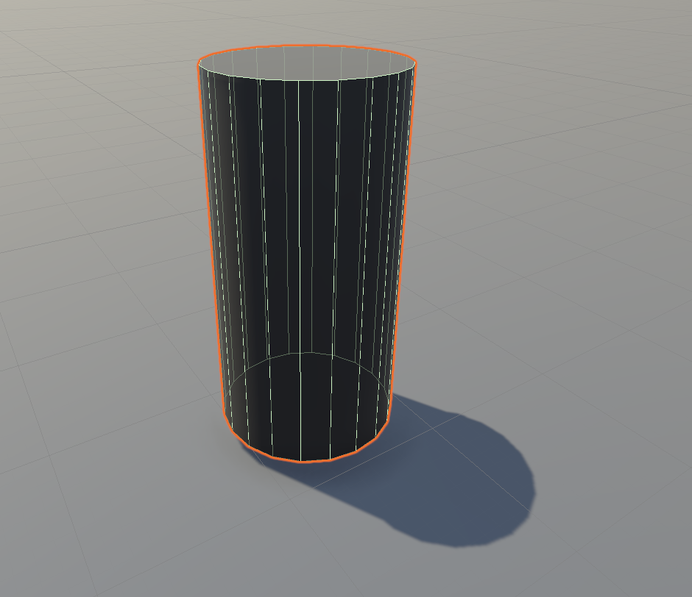
Another situation where your collider might not match your mesh is when scaling a sphere to a non-sphere shape. The sphere collider always retains its perfectly spherical shape, so you will get a mismatch. Check out the example below of the default Sphere Collider component compared with a Mesh Collider component on a scaled sphere.
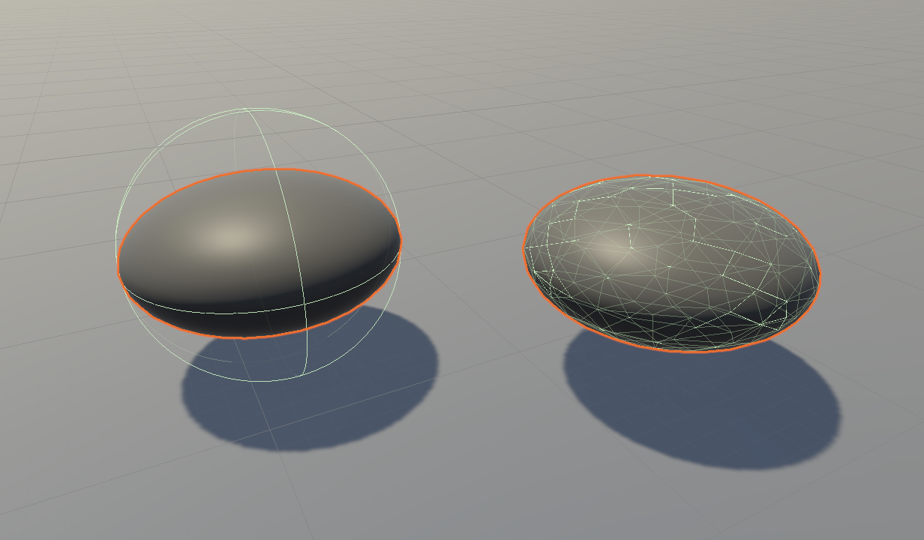
To swap out the default collider with a convex Mesh Collider component, watch the video below.

4. Instructions
With the guidance above in mind, use the following instructions to create your own scene:
1. Choose a design.
- You can either recreate one of the example structures above, find other inspiration, or use your imagination to design something unique.
2. Create a new scene.
- Start fresh by creating a new Unity scene.
3. Create the ground.
- Add a plane GameObject to serve as the foundation for your structure.
4. Build your structure.
- Add various primitive shapes (like cubes, spheres, capsules, or cylinders) to assemble your structure.
5. Enable gravity.
- Add a Rigidbody component to your primitives, so they obey the laws of physics.
6. Position the camera.
- Make sure to position the camera to nicely frame your creation.

5. Requirements

To successfully complete this challenge, your Unity sculpture should meet the following criteria:
- It Incorporates at least two different types of primitive shapes.
- All objects must have a Rigidbody component with the Use Gravity property enabled.
- It remains standing when you switch to Play mode.
- It has a custom material applied to the GameObjects for a visually engaging aesthetic.

6. Submit your work

After you’ve fulfilled the requirements, please submit and share your project! Follow these instructions to submit your project:
1. Take a screenshot or screen recording of your project in Play mode.
2. Add a submission title and description.
- Make sure to include the image or video of your project. If you have additional details to share about your process or the project that you have created, you can share them in the description too.
3. Set who can view your submission.
- Public: Anyone who views this tutorial.
- Private: Just you.
4. Select Save and preview submission.
5. Check your submission preview and then complete the CAPTCHA test and select Submit and continue.
We highly recommend that you comment on at least one other creator's submission. Did they successfully complete the challenge? What do you like about the project?

You can record your Unity project screen and gameplay using the official Unity Recorder Package. [1]
Install the Recorder
- Open your project in Unity.
- Go to Window > Package Manager.
- Change the package source to Unity Registry.
- Search for Recorder, then click Install. [1]
Open the Recorder Window
- Go to Window > General > Recorder > Recorder Window. [1]
Configure the Settings
- Click + Add Recorder in the window and select Movie.
- Set the Source to Game View (or a specific target camera).
- Choose your target Resolution (such as 1080p) and format (H.264 MP4).
- Pick a file name and check the output path (saved in a recordings folder by default). [1, 2, 3, 4]
Record Your Project
- Click the Play button in the Unity Editor to start your game.
- Click the Start Recording button in the Recorder window.
- Click Stop Recording when you are done, then exit Play mode.

